Astoria Park’s

Parents’ Guide to Distance Learning



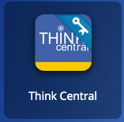

**Math Guide**

Here is an outline on how to complete your child’s weekly assignments and test. Please feel free to contact me if you have any questions!

**Step 1:** Log on to class link at <https://launchpad.classlink.com/leonschools>

Username: [student#@edu.leonschools.net](mailto:student#@edu.leonschools.net)

Password: 12345

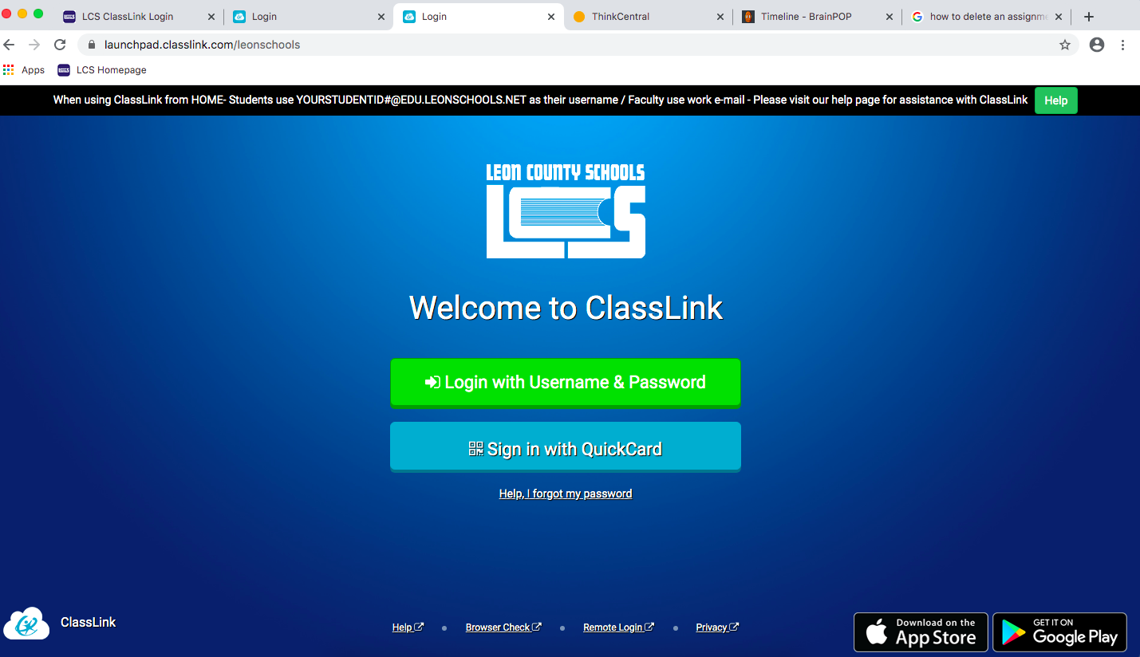

**Step 2:** click on the “Think Central” tile

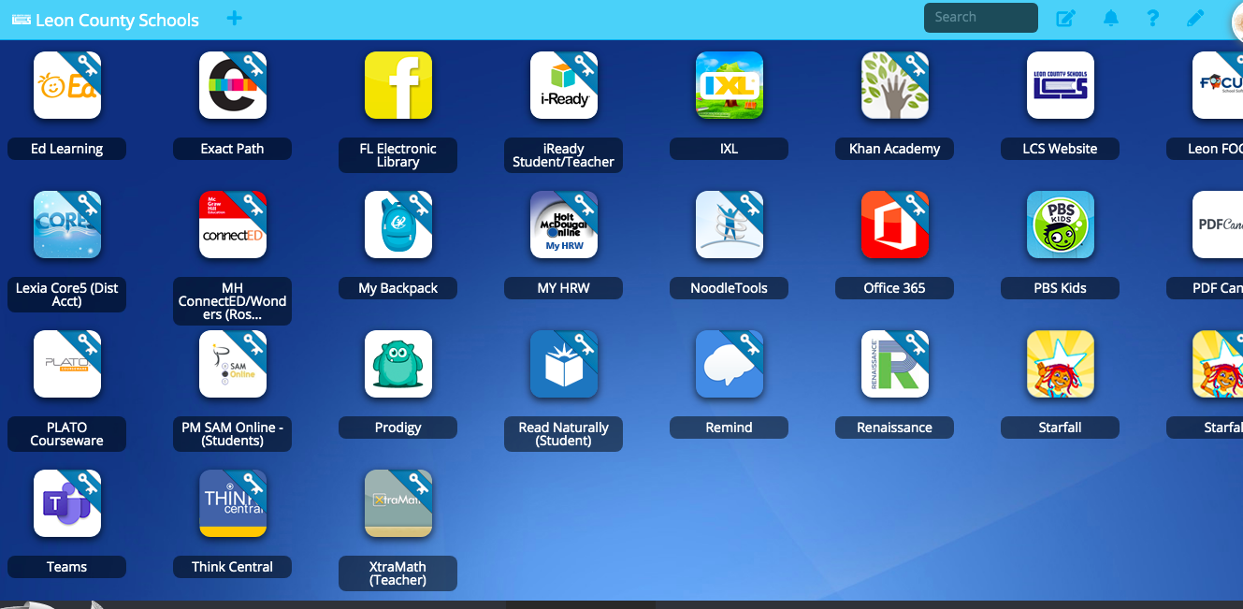

**Step 3:** click on “Things to do”

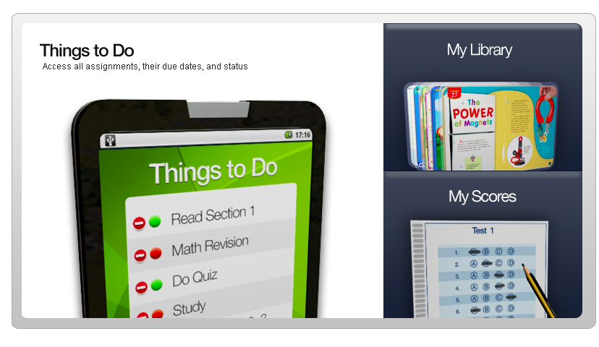

**Step 4:** click on the assignment

t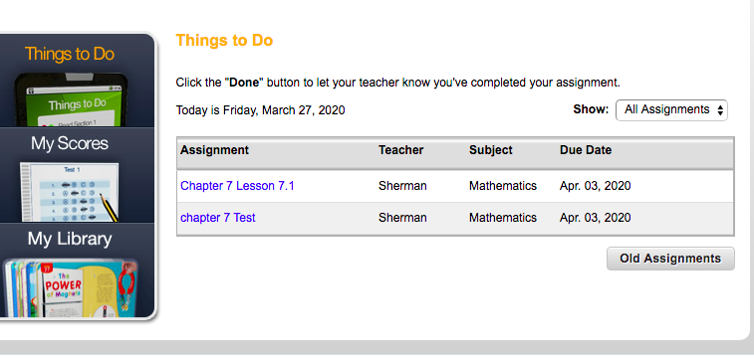

**Step 5:** Start the lesson(Please complete all lessons assigned before completing the test.)

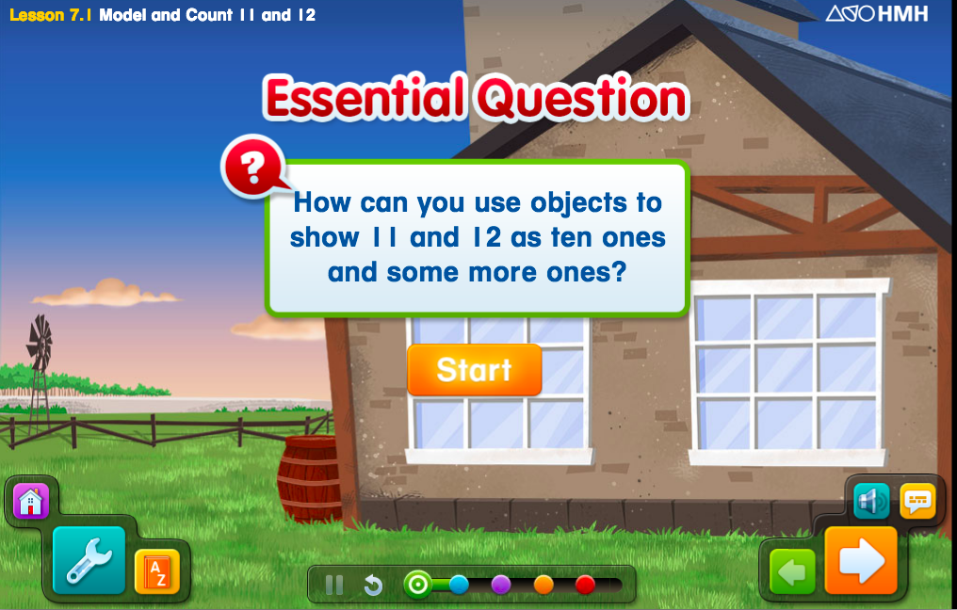

**Step 6:** Once you complete the green, blue and purple section, continue to the orange section and click on the personal trainer icon to complete the elaborate section

**.**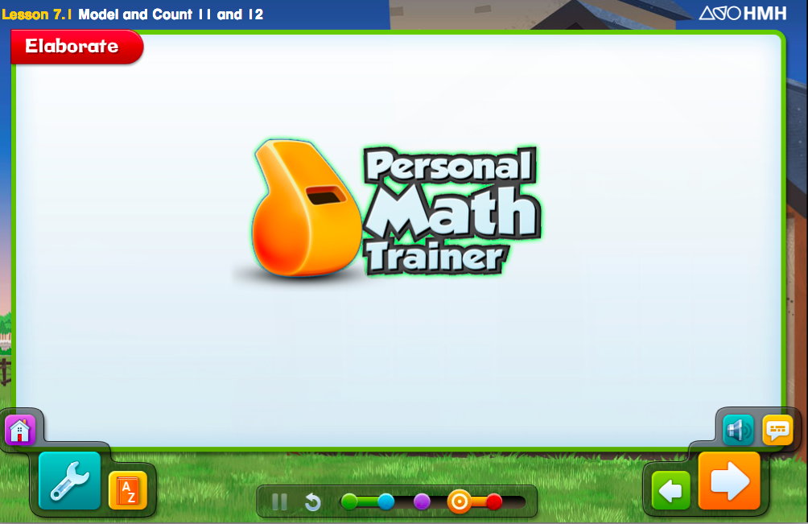

**Step 7**: Once you are done with the elaborate section, click “turn it in” on the right side

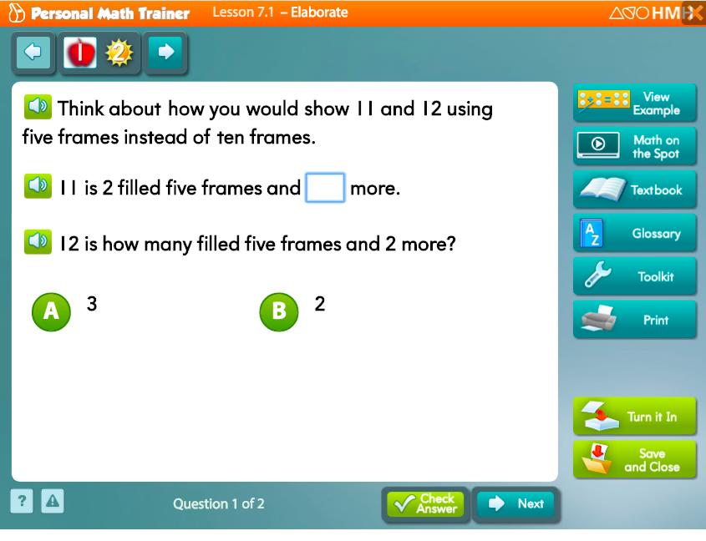

**Step 8:** Next, go to the evaluate slide and repeat steps 6 and 7 to complete assignment. Then you can move on to the next lesson.

.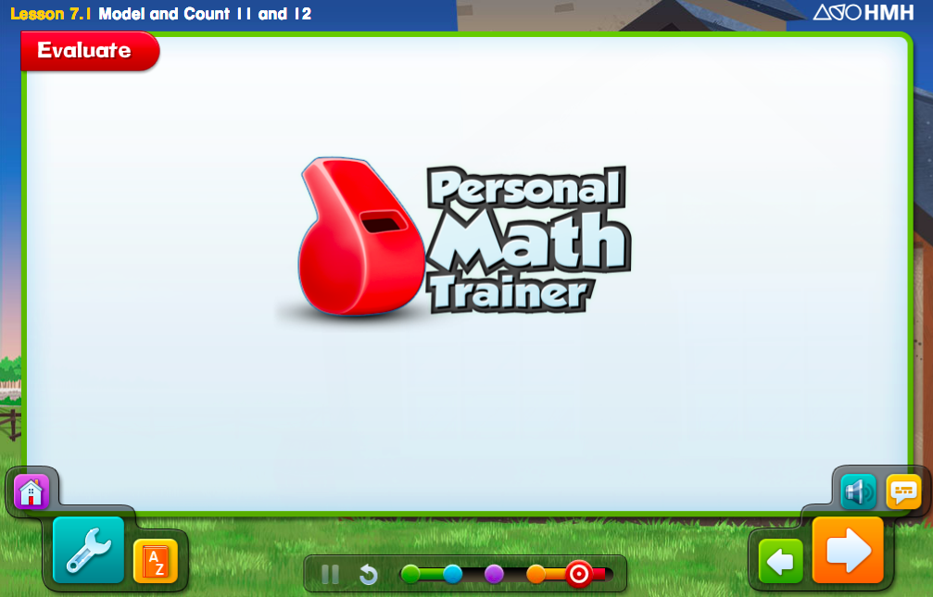

**How to take the Math assessment**

**Step 1:** click on “Things to do”

**Step 2:** click on “Test” (please refer to example in Step 4)

**Step 3:** click on “Start Test”. Choose an answer and then hit the next button (you may have to scroll down to see all the answer choices as well the next button)

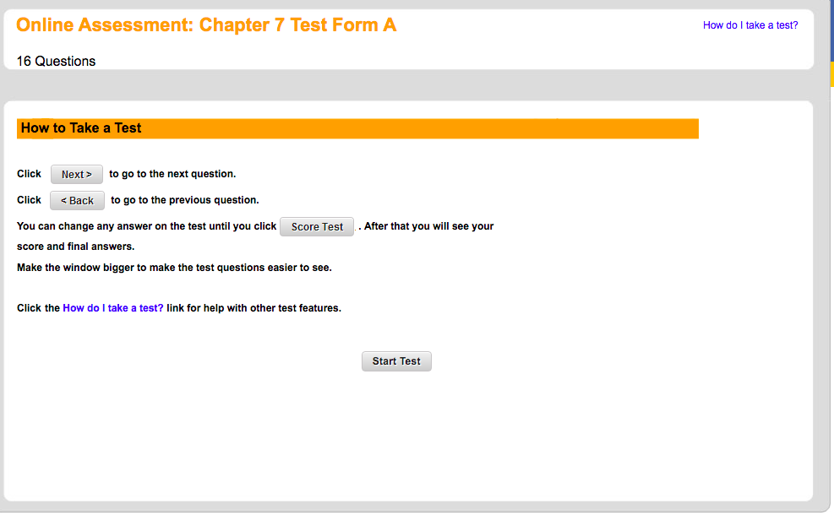

**Step 4:** Hit score test once you are done. If you skipped a question, it will show you the number you missed. Just click on it and it will take you back to your question.

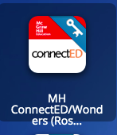

**Reading Guide**

Here is an outline on how to complete your child’s weekly assignments and test. Please feel free to contact me if you have any questions!

**Step 1:** Log on to class link at <https://launchpad.classlink.com/leonschools>

Username: [student#@edu.leonschools.net](mailto:student#@edu.leonschools.net)

Password: 12345



**Step 2:** click on the “Connect Ed” tile



**Step 3:** click on “Launch” (Each grade level will look a little bit different but the steps are still the same.)

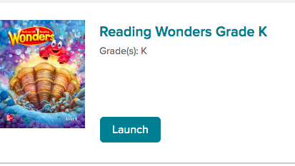

**Step 4:** Once you click on Launch, you will be taken to the main screen that has a lot of different resources.

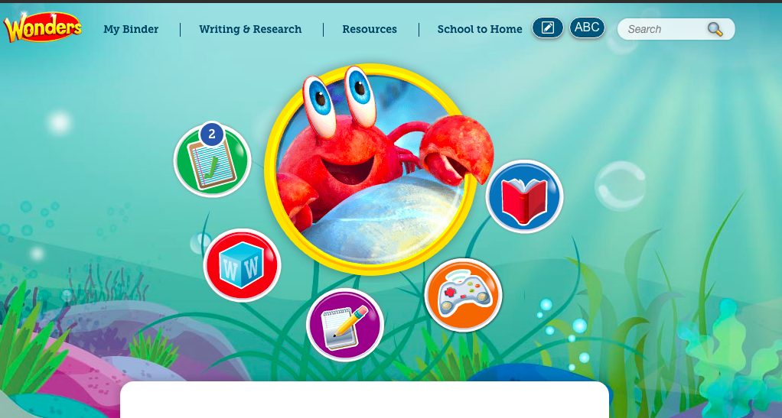

**Red Book**- It will have all of the reading literature for the Wonders’ week

**Orange Games**- The games will help your child practice the skills of the week

**Purple Notes Circle**- This allows your child to practice writing skills

**Red Circle**- This contains the words your child should review

**Green Circle (To do list)-** This is where you will find all of your child’s assignments.

**My Binder**- This will contain all of your child’s finished assignments and tests

**Writing and Research**- Contains writing activities

**Resources**- This contains all of the resources available in the Wonders curriculum

**School to Home-** This is a parent letter describing the skills for the week.

**Step 5:** Play all of the Wonders games before completing an assignment. You may also want to read the literature provided.

**Step 6:** click on the “To Do List” and it will take you to all of the assignments for the week. It will also have your test but please complete all of the assignments before completing the test.

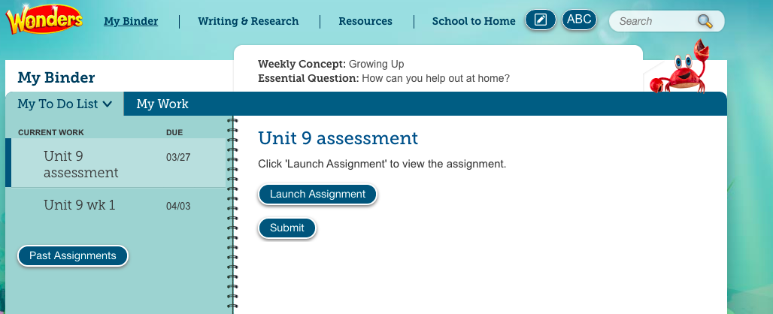

**Step 7:** Click on the practice workbook pages to complete assignments.

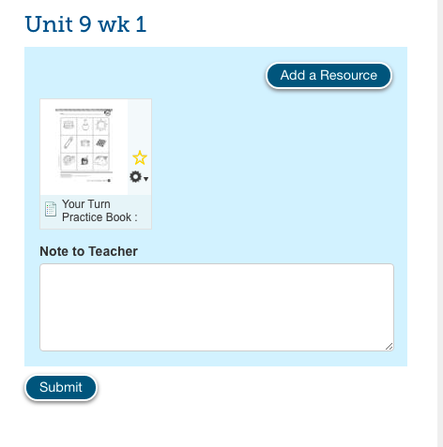

**How to complete assignments**

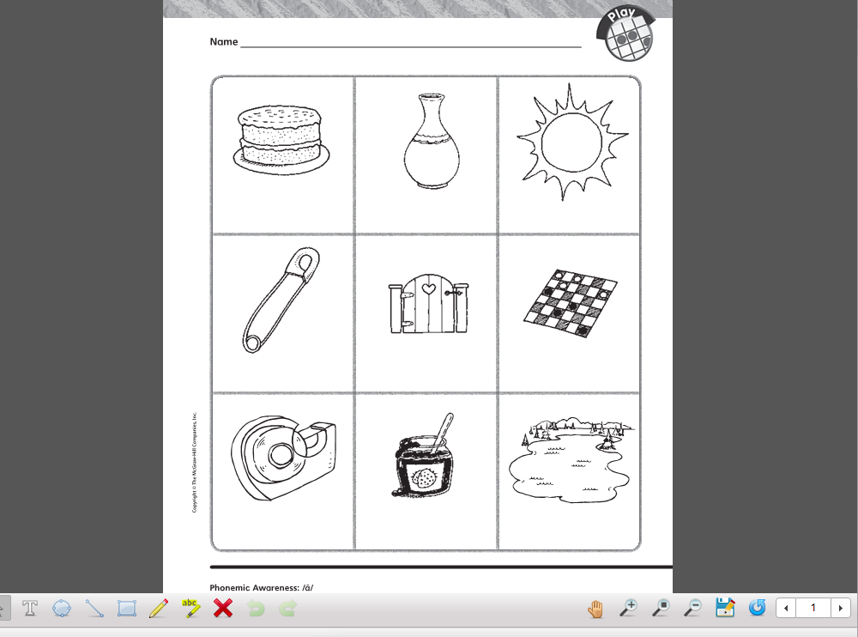

1. Click on the pencil located down at the bottom to write and hit the save button (blue floppy disk).
2. Then hit the arrow down at the bottom to move on to the next page. Make sure you are hitting the save button so that the assignments are saved in the binder.

**Step 8:** Hit the submit button located at the bottom of the assignment and then you should see a green check next to the assignment showing that it is completed.

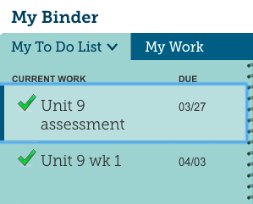

**Step 9:** After you completed all assignments and you know your child is ready for the test, you may start the assessment. If you don’t’ know if your child is ready for the test, feel free to play the Wonders game or contact me. Your child will only get one chance to submit the test so please make sure that your child takes his/her time. You may have to scroll down to see all available answer choices and make sure to hit the “next button” to move on to the next question.

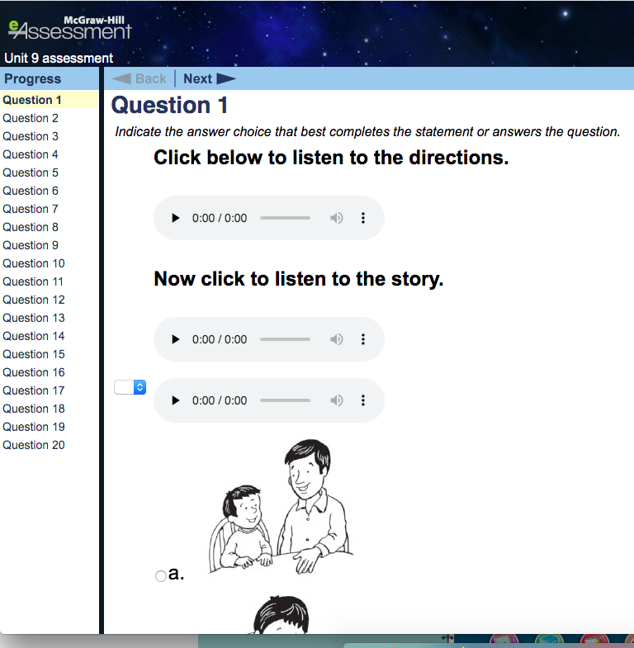

**Step10:** Submit the assignment

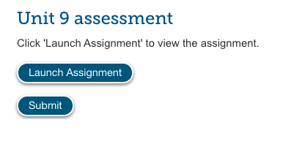

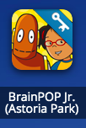

**Brain Pop Jr. (Science and Social Studies Assignments)**

**Step 1:** Log on to class link and located the Brain Pop Jr. tile. Click on it and then click on the dashboard.



**Step 2:** Watch the video first and then complete the quiz